How to Manage Orders and Referrals
Contents
Finding an Order Using the Preference List 2
Printing Signed Orders 9
To Print External Imaging Orders to Fax 9
To Print External Lab Orders to Fax 11
Faxing Orders from Within Epic 13
Editing Associated Diagnosis Codes on Signed Orders 15
Creating Favorite Orders 18
Removing Orders from the Favorites List 20
Creating and/or Editing an Order Panel 21
Following Other’s Favorites Lists 25
Delete or Discontinue Orders 28
Cancel From Order Review 28
Cancel from Enter/Edit Results 30
Cancel from ANC Orders 33
Changing an Order from ANC Orders 37
Deleting Pended Orders from a Canceled Appointment 39

Finding an Order Using the Preference List
- Click the Preference List (next to Add Order) 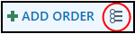 button in the Visit Taskbar at the bottom of the screen.
- Click the arrow next to Labs in the Navigator on the left side.
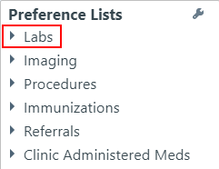

- Click Labs - All Labs.
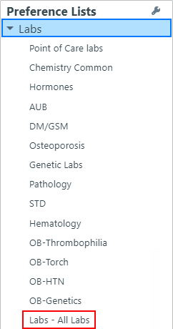
- Select the appropriate orders by clicking the check box next to the order.

- Click Accept.
- Click Dx Association in the order details box.


An Associate Diagnoses window opens.
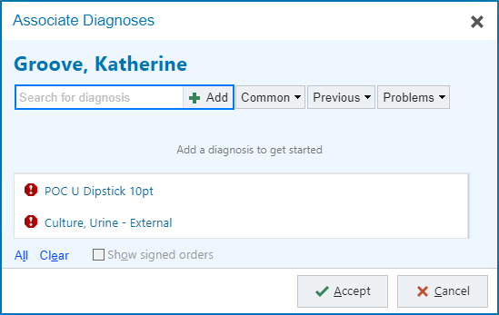

This window can be used to associate diagnosis codes to all unsigned orders. There are multiple ways to bring in diagnosis codes.

Search: Use the Search for diagnosis field to search through all available diagnosis codes. Simply type the code in and click Add or press enter.

Common Dx: Click this drop down menu button to access your personalized list of common diagnosis codes.
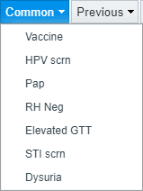
Previous: Click this drop down menu button to access a list of previous diagnosis codes this patient has been given.
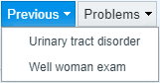

Problems: Click this drop down menu button to access the patient’s currently active Problem List.
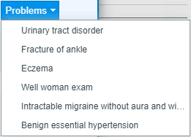

- Choose the appropriate diagnosis code for the orders using one of the methods above.
- Check the boxes to associate the diagnosis codes to the orders.
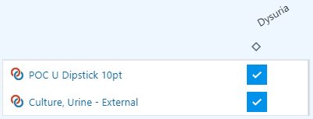

- Click Accept.

Notice that some order may have a hard stop . This means there is additional work to complete prior to signing the order.
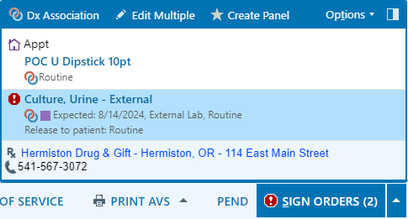

- Click the Urine Culture to open the order.

Notice that the Status is set to Future. There are three different statuses that can be set in an order.

Normal: Indicates a test that is intended to be completed one time, TODAY within the current visit encounter. Point Of Care (POC or POCT) orders are defaulted to this Status.

Standing: Indicates that a test is to be completed multiple times, such as with serial draws at specific intervals. These can either be automatically released or set to be manually released to orchard from Epic.

Future: Indicates that the test is to be completed one time, either today or in the future outside of the provider’s visit encounter. The majority of WHA’s labs default to this status. When ordered in this status the order is immediately released into Orchard, our lab processing software, for use. In this status, we can change the expected date, which is visible to the site lab staff working out of Orchard. This also drives when tests drop into the Overdue Results folder for follow-up if not completed in a timely manner.

Also notice that the Expected Date is set for Today. All tests, outside of POCTs, that need to be collected either today or in the future, need to be ordered under the "Future" Status. It is really important that the Expected Date is updated to either the exact date in the future or an approximate date in the future where this test is to be collected.

Updating the expected date will help ensure that the lab staff can easily see when something is supposed to be collected in Orchard, which helps to avoid collection at the wrong time, it also helps ensure that any tests that have not been completed drop into the overdue results folder for follow up at the right time.

- Ensure the Status and Expected Date are appropriate for this patient’s order.
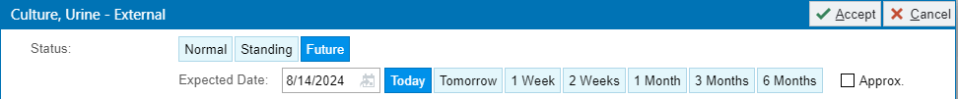

- Satisfy the hard stops using the options available for the Sources.

- Click Accept.

At this point, we are unsure if our provider will decide to send the urine culture or not. So, we will only sign the POC order.

- Click the arrow pointing up next to the Sign Orders button. 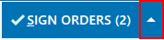
- Click Selective Sign.
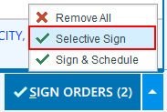
A Selective Signing of Orders box will open.

- Check the box next to the POC dip order.
- Click Accept.
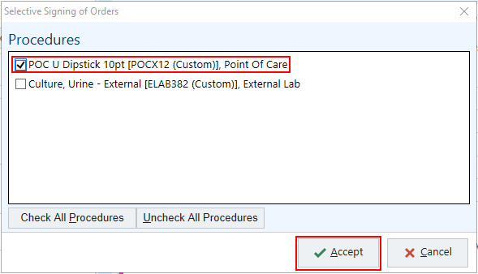

The Provider’s window opens.
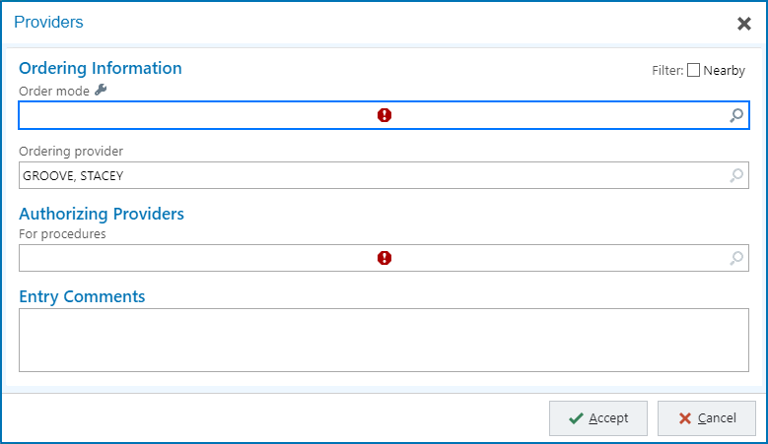

- Enter in Order Mode: AMB, then tab. AMB Scheduled Ord Protocol will auto populate into box.
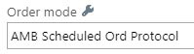

  - This can be made into a button by clicking the Wrench next to Order Mode.
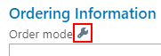
  - An Order Mode Quick Button Settings window opens.
  - Type amb into the Order Mode field.
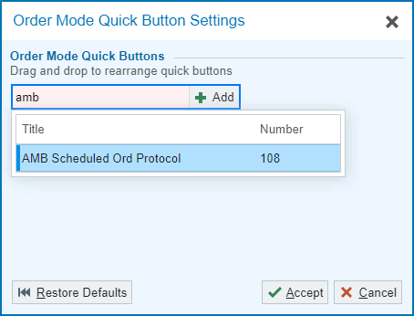

  - Click Add or press enter.
  - Click Accept.
  - The button is now available under Order Mode in the Provider’s window.
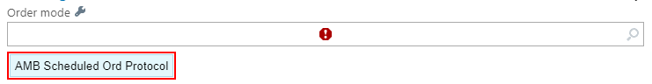

- Document the Ordering and Authorizing Provider.
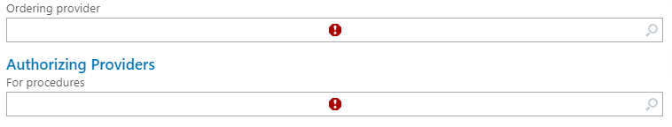

- Click Accept.

Printing Signed Orders

To Print External Imaging Orders to Fax
- Go to Chart Review
- Click the Other Orders tab

- Click the order that needs to be printed to highlight it
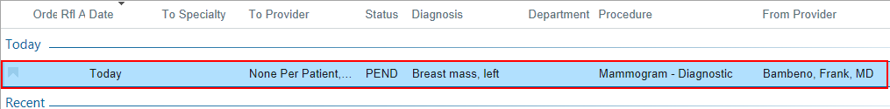

- Click Print
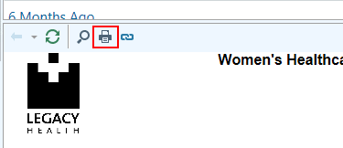

- Leave all boxes in the pop up unchecked and click Continue.
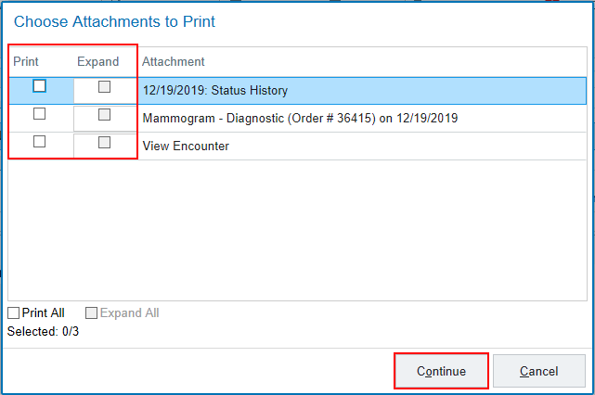

- Select your printer and click Print.
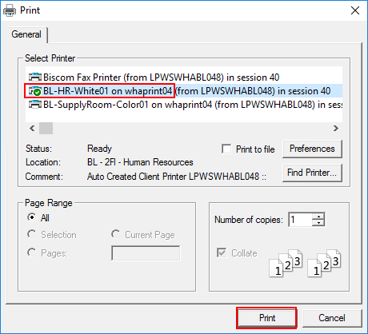

To Print External Lab Orders to Fax
- Go to Chart Review
- Click the Labs tab
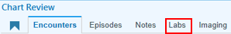

- Click the order that needs to be printed to highlight it

- Click Print

- Leave all boxes in the pop up unchecked and click Continue.
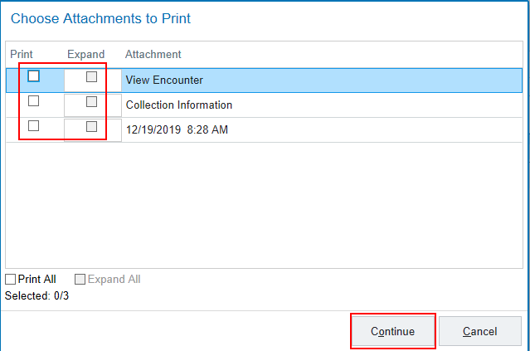

- Select the printer you want it to print from and click Print.

Faxing Orders from Within Epic
At times it will be necessary to fax orders to outside facilities, such as external imaging orders. This can be done from within Epic using the Route activity (unless the order requires a wet signature like external imaging orders being faxed to Providence). To be able to use this functionality within Epic, the order must be signed and active, not pending.
- While in Chart Review, navigate to the appropriate tab.
  - Labs : for labs being completed outside of WHA
  - Other Order : for external imaging and other referrals like Physical Therapy and DME
- Single-click the order that needs to be sent out.
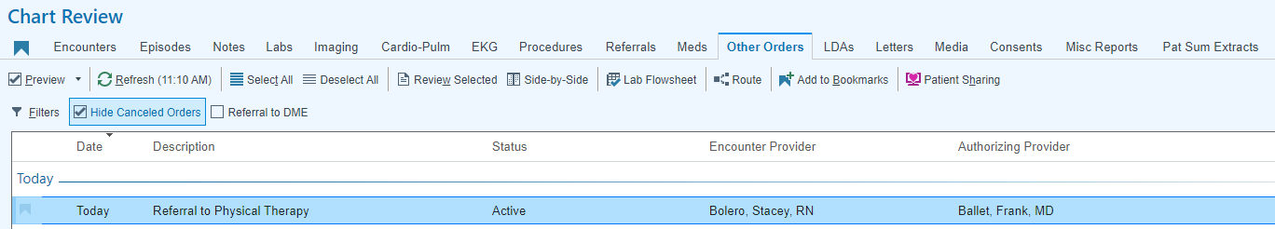

- Click the Route button.
A Route Other Orders box opens.
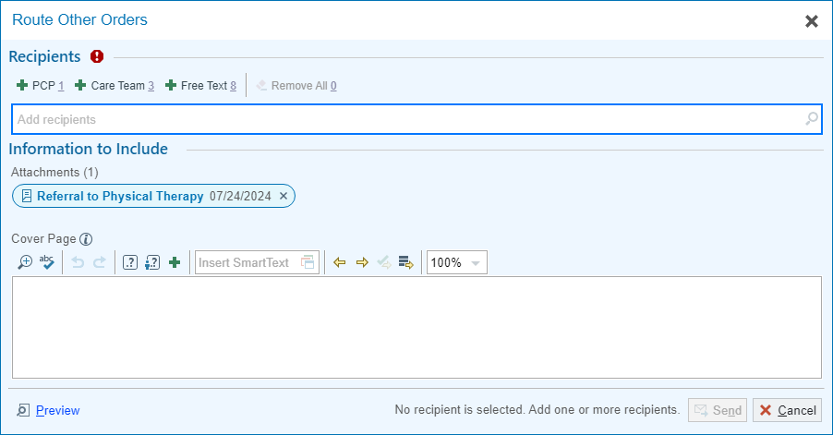

The order will show as an attachment in the Information to Include section.
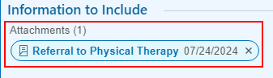
- Add a recipient in the Send To field. This is also a search box for potential recipients.
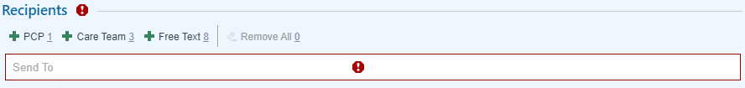
  - Speed buttons for the patient’s PCP, Care Team, and Free Text are available.
**Note: If you find that there is a contact that you use often and it is not in the available list, send an email to IT to have the contact added. Make sure you include: the Name of the contact/Organization, Phone and Fax numbers, and Address.**
- Add a Cover Page message if needed.
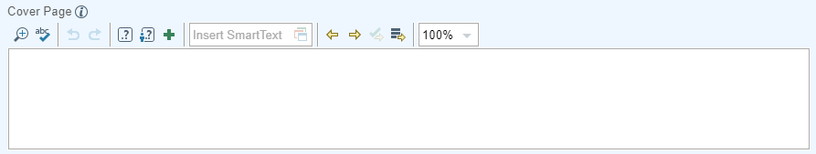

- Click Send .
Anything that has been sent using the Route button can be tracked using the AMB Chart Review: Routing Hx report in the Misc Reports tab in Chart Review.
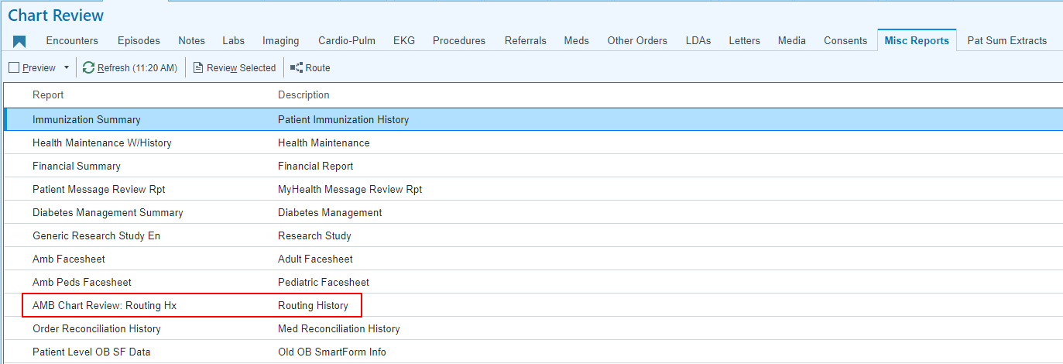

Editing Associated Diagnosis Codes on Signed Orders
Unfortunately, there are times when orders are signed with incorrect diagnosis codes. Fortunately, there is an easy way to correct these errors.
- Open the encounter that the order was placed in. If it has already been signed, create an addendum.
- Go to This Visit 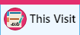 activity.
- Scroll to the Medication Management activity.
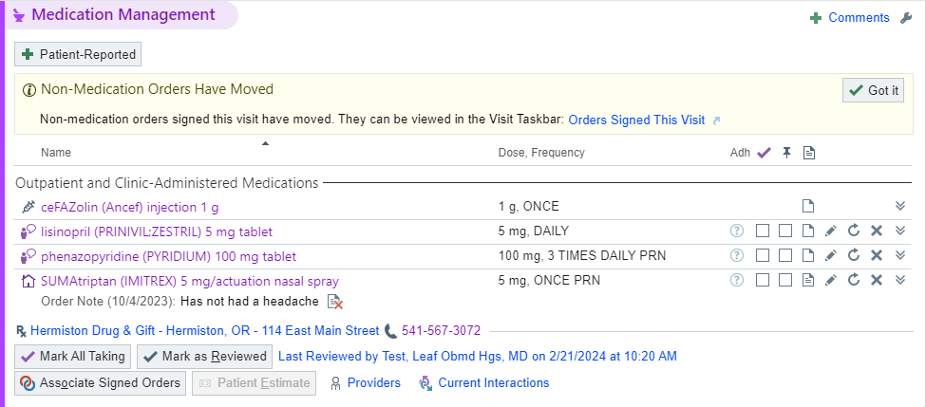

- Click the Associate Signed Orders button.
The Associate Diagnoses window opens.
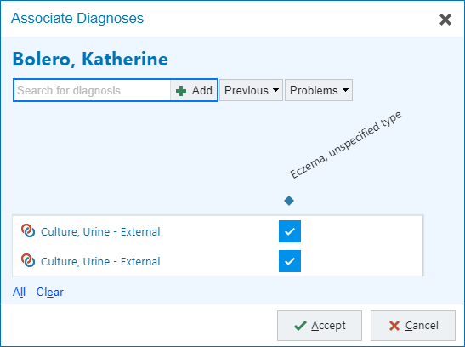
- Unselect the checkboxes that associate the order with the incorrect diagnosis code(s).
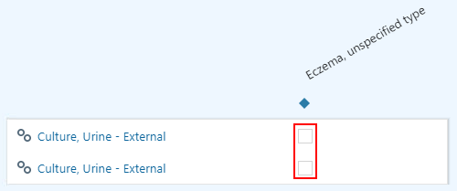

- Using the Search for diagnosis field, the Previous drop-down list, or the Problems drop-down list to find the appropriate diagnosis code(s).

- Once the codes have been chosen, click the checkboxes to associate the appropriate code(s).
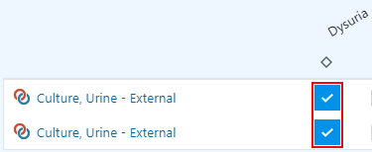

- Click Accept 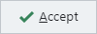

A Dx Association window opens.
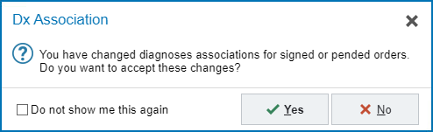

- Click Yes 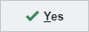
- If an addendum was created, click Sign Addendum.

Creating Favorite Orders
- Open the Preference List.
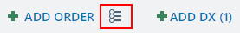

- Find the order to be favorited and right-click.
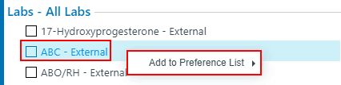

- Hover over the Add to Preference List button and click which category the order belongs to.
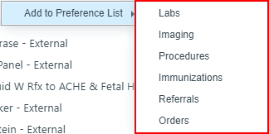

An Add to Preference List window will open.
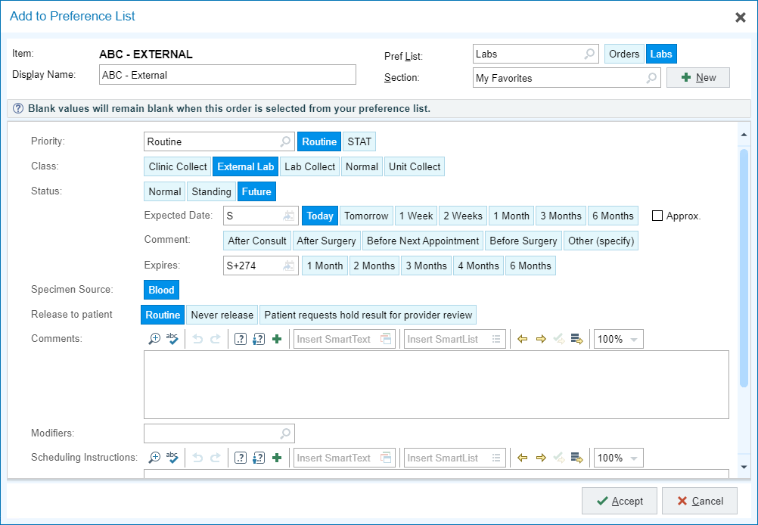
- Update the Display Name if necessary.
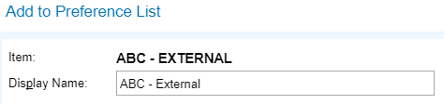

- Click Accept 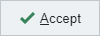

Notice there is now a My Favorites checkbox available in the Preference List.
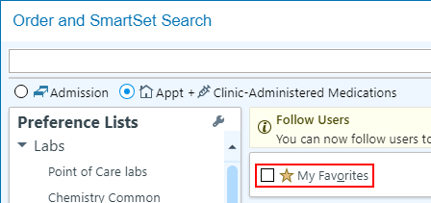

When the box is checked, only the list of favorites will be visible.
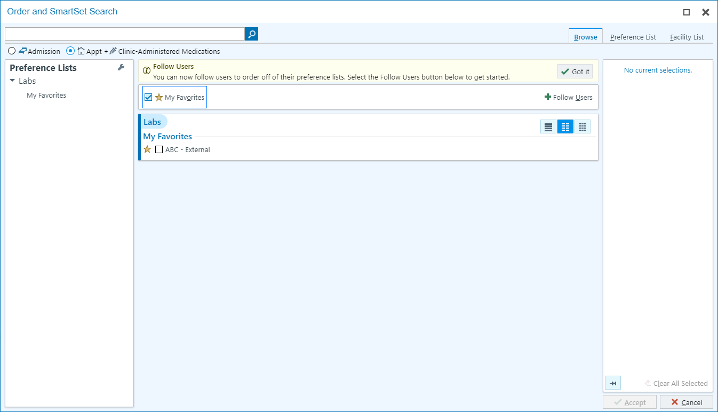

Removing Orders from the Favorites List
- Open the Preference List in an open encounter or pre-charting.

- Find the My Favorites section.
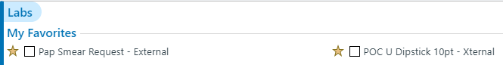

- Right click the order that needs to be removed.
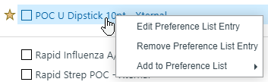

- Click Remove Preference List Entry button. 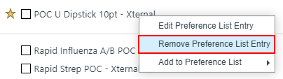

- Click Remove.
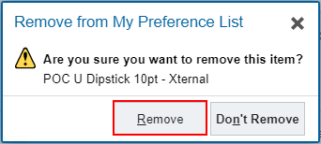

Creating and/or Editing an Order Panel
It’s important to know that creating a panel saves it to your favorites list. When you do this, the orders do not get updated when IT/Applications makes changes to the presets in the Preference List. Please remember to go in and resave your favorites and panels every time you’re notified when orders have been updated. Or, every now and again, you can go in and re-favorite panels to ensure your orders are not out of date.
- Open the Preference List.
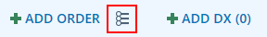

- Select the orders that will be included in the panel.
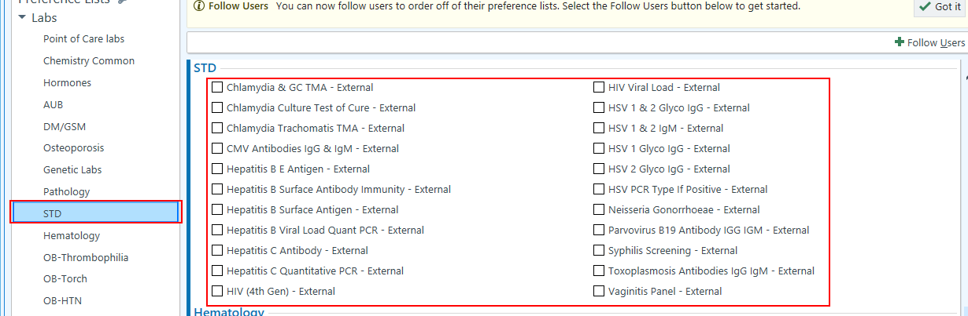

- Click Accept.
- Click Create Panel.
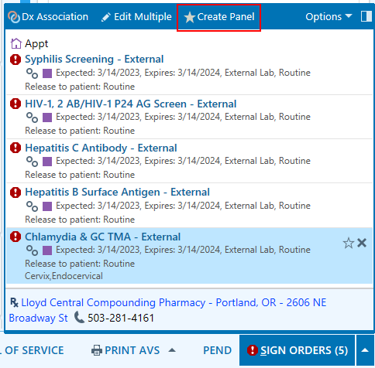
- Name the panel.
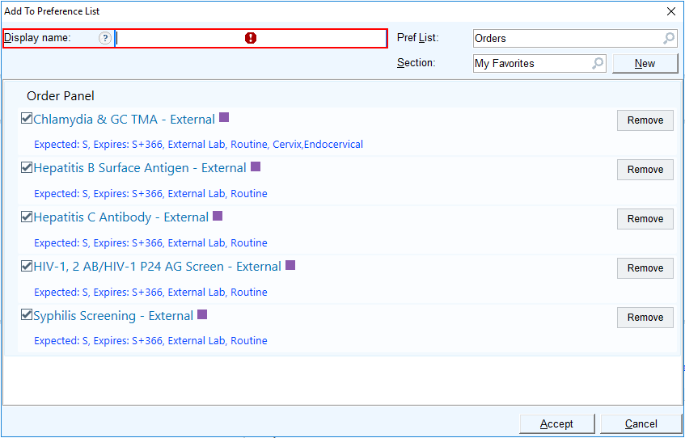

- Click Accept.
- The panel will now be visible in your favorites.
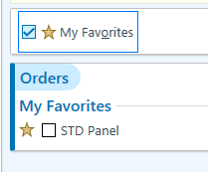
Once the panel has been created, it can be edited at any time.
- Open the Preference List.

- Notice the My Favorites checkbox. Single click to view only your list of favorited orders.
- Find the panel that needs to be edited and right-click.
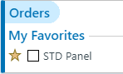

- Click Edit Preference List Entry.
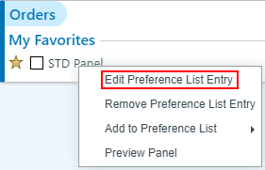
An Edit My Preference List Defaults window will open.
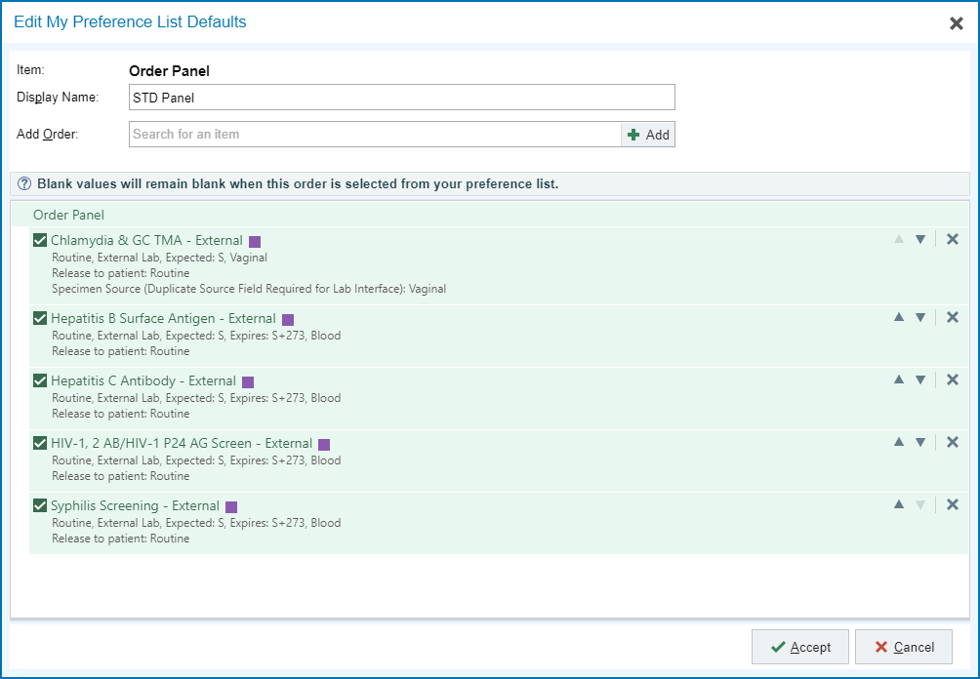
From this window you can add or remove orders, as well as reorganize the orders.
To add orders use the Search for an item field.
To remove orders click the X next to it.
To reorganize the orders use the up and down arrows next to the X on the order to change where it lies in the panel.
To change the order details for each order, click the details to open the Order Details box and adjust accordingly.
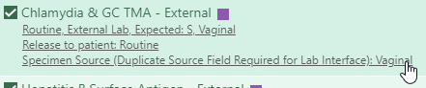

Following Other’s Favorites Lists
There may be instances where you find that other staff have set up a list of favorite orders that you want to use. You have the ability to follow other users’ Favorites Lists. This can be especially useful if you have a steady provider that you work with most of the time.
- Open the Preference List.
The Order and SmartSet search window opens.
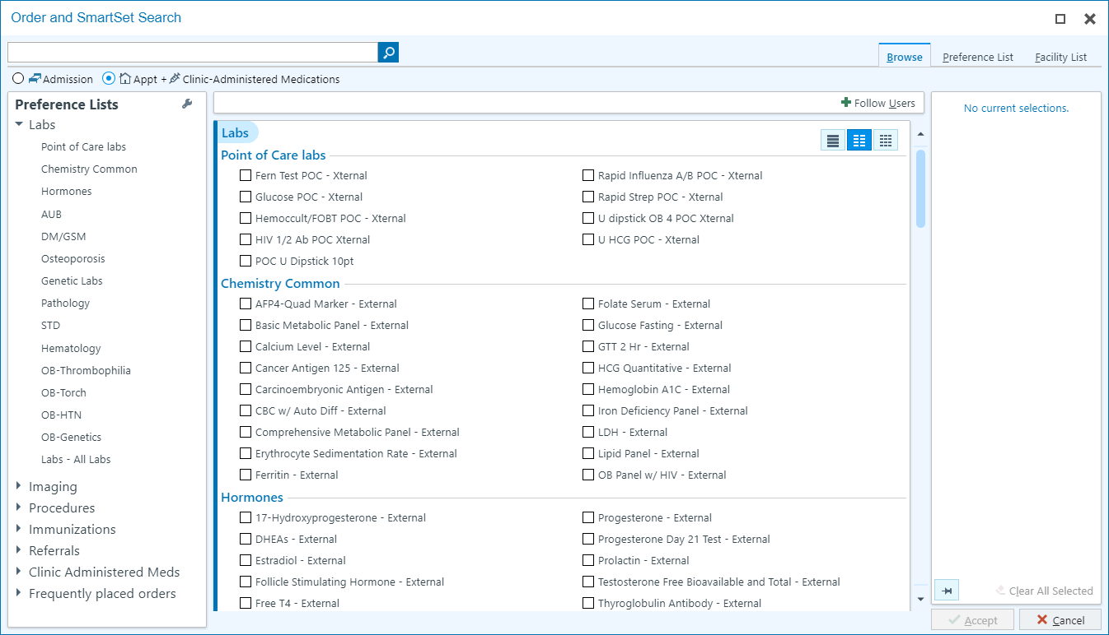
- Click the Follow Users button.
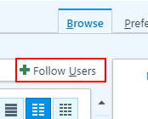

A Follow User’s Preference Lists window opens.
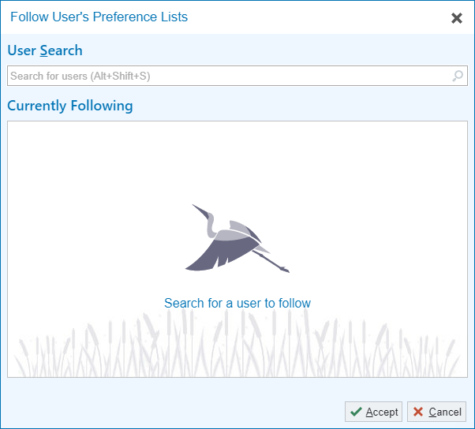
- In the Search for users field, type the name of the user and press enter.
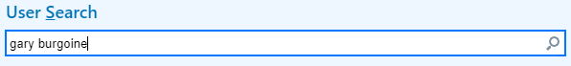

- The user will be added to the Currently Following section.
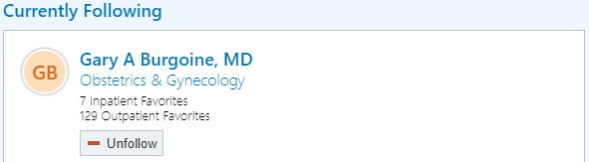
  - To unfollow the list, click the Unfollow button.

- Click Accept .
Once the window closes, the user’s preference list will be visible. If you check the box next to the user’s name, only that user’s favorites list will be visible.
When the box is unchecked, at the bottom of each section of the Preference List the user’s favorites will be present for use.
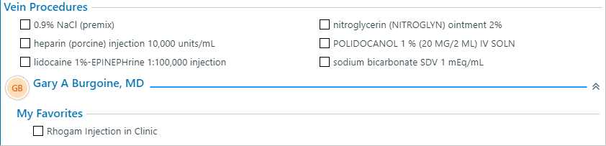

Delete or Discontinue Orders

Cancel From Order Review
Many different orders can be discontinued from Order Review. These include Labs, Imaging, Medications, Charges, Immunizations and more.
- From a patient’s chart, click on Order Review. 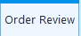
  - If it is not on the top bar, you may have to look under Open additional activity.

There may be times when you aren’t able to see the order you’re looking for. This can be due to a few different reasons. One of the main reasons is that you need to adjust your Views or Filters in Order Review.

Views is most helpful when looking for specific Labs and Meds. The default view is All Active Diagnostics.
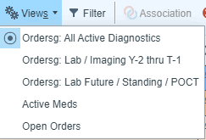

Filters is helpful when you’re looking for other order types like imaging and referrals.
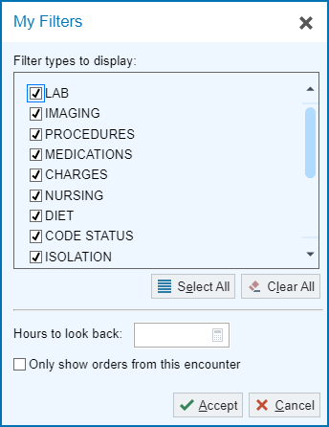

- Click to select the order you would like to delete, and press Discontinue. 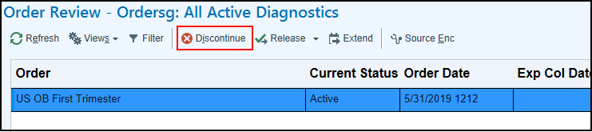
- Choose a reason for canceling by clicking on the magnifing glass . Add any additional comments if necessary and then press Accept. 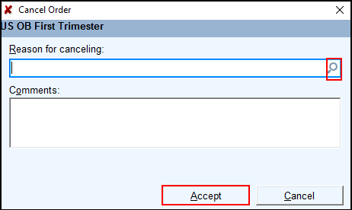

Notice that the order is now gone.
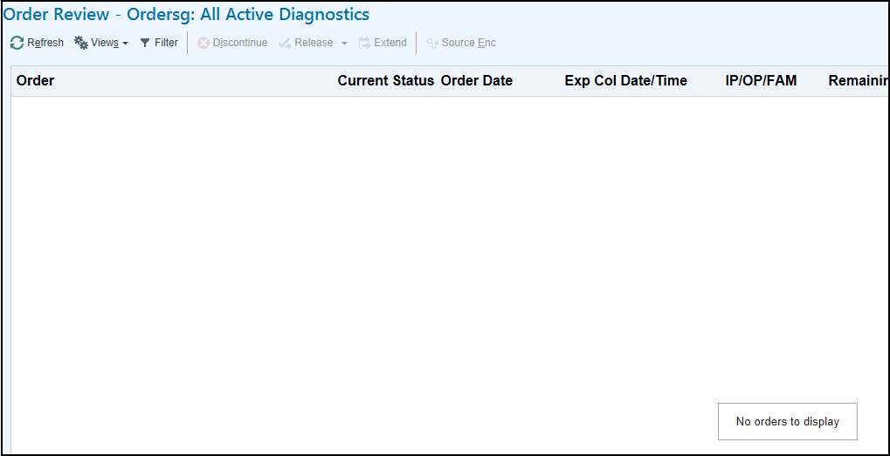

Cancel from Enter/Edit Results
Most types of orders can be deleted from Enter/Edit Results. However, there is a filter that is defaulted on the activity to ensure it only shows POC orders. If the Default Types filter is unselected, you can discontinue most types of orders from this activity.
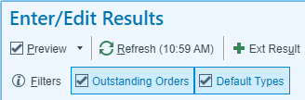
- Go to patient’s chart
- Select the Enter/Edit Results 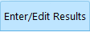 activity located at the top of your screen. Or use the drop down arrow to open the activity.
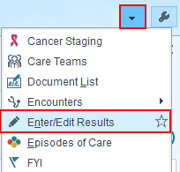

- Single-click to highlight the order(s) to be discontinued.
- Click Cancel Order located in the activities at the top of this order view.
The Cancel Order window automatically opens.
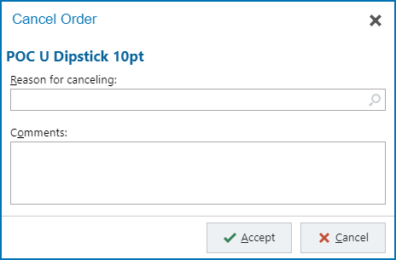
- In the Reason for canceling box click the magnify glass to find an appropriate reason.
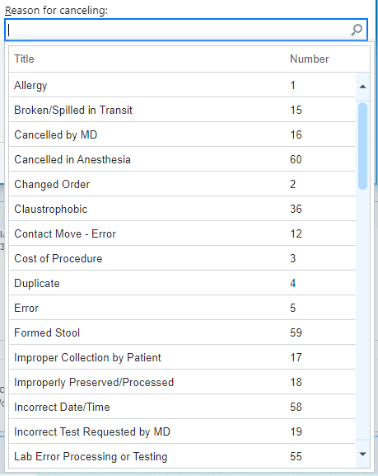

- Click Accept.
- Your selected reason is now listed in the box.
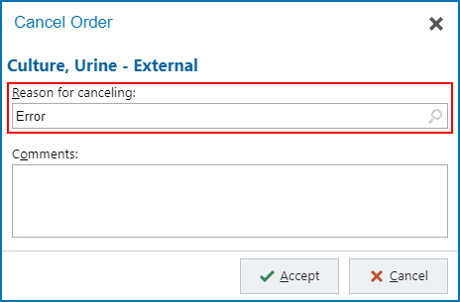

- Click Accept.
- Notice that the order is no longer seen.
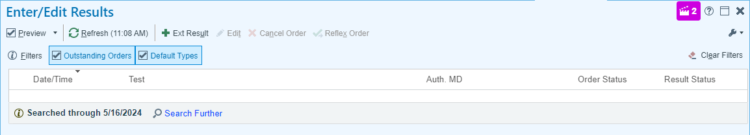

- Return to the Labs tab in Chart Review.
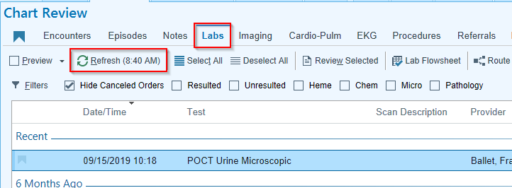
- Click Refresh to update this tab.
- Uncheck the box next to Hide Canceled Orders to see the discontinued labs.
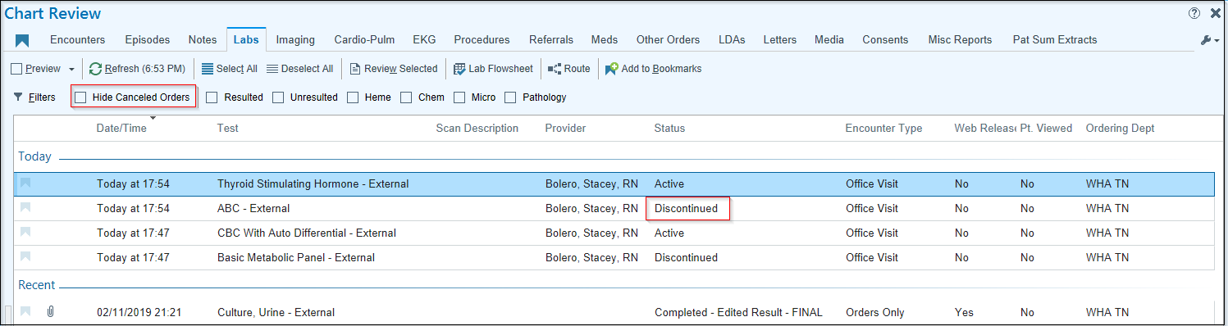

Cancel from ANC Orders
Anc Orders is best used for changing and cancelling WHA and Legacy based imaging orders.
If you have an external order (anywhere outside of WHA and Legacy) you will need to cancel the order and put in a new order.
- Open the Anc Orders activity. It may be in your hyperspace toolbar, or found by clicking the Epic button and going to scheduling. Select your patient.
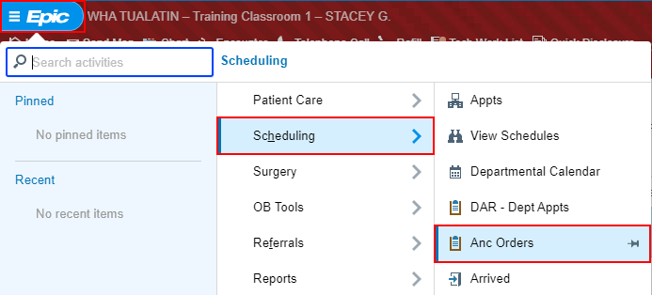

Once a patient is selected, the Ancillary Orders – (New) window will open.
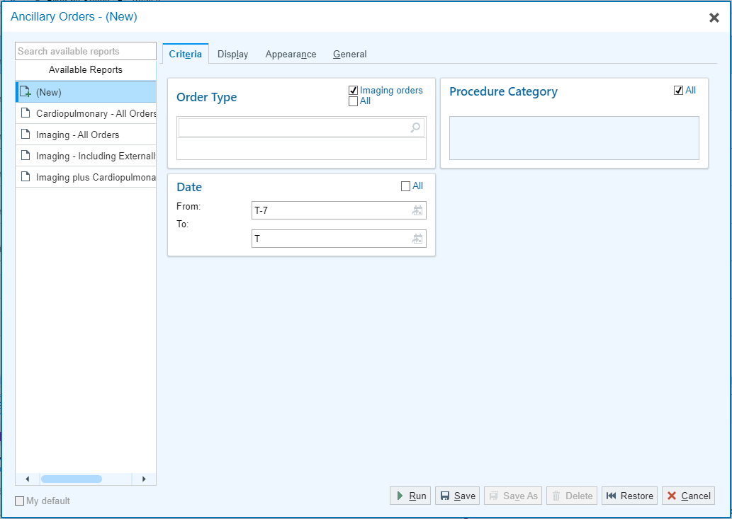
It will default to having the Imaging Orders box checked in Order type. Uncheck this box if you are looking for any other order type.
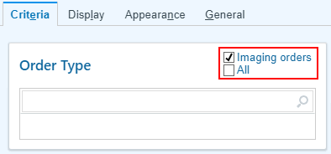

- Select the appropriate Order Type.
- Click Run

The Ancillary Orders activity opens.
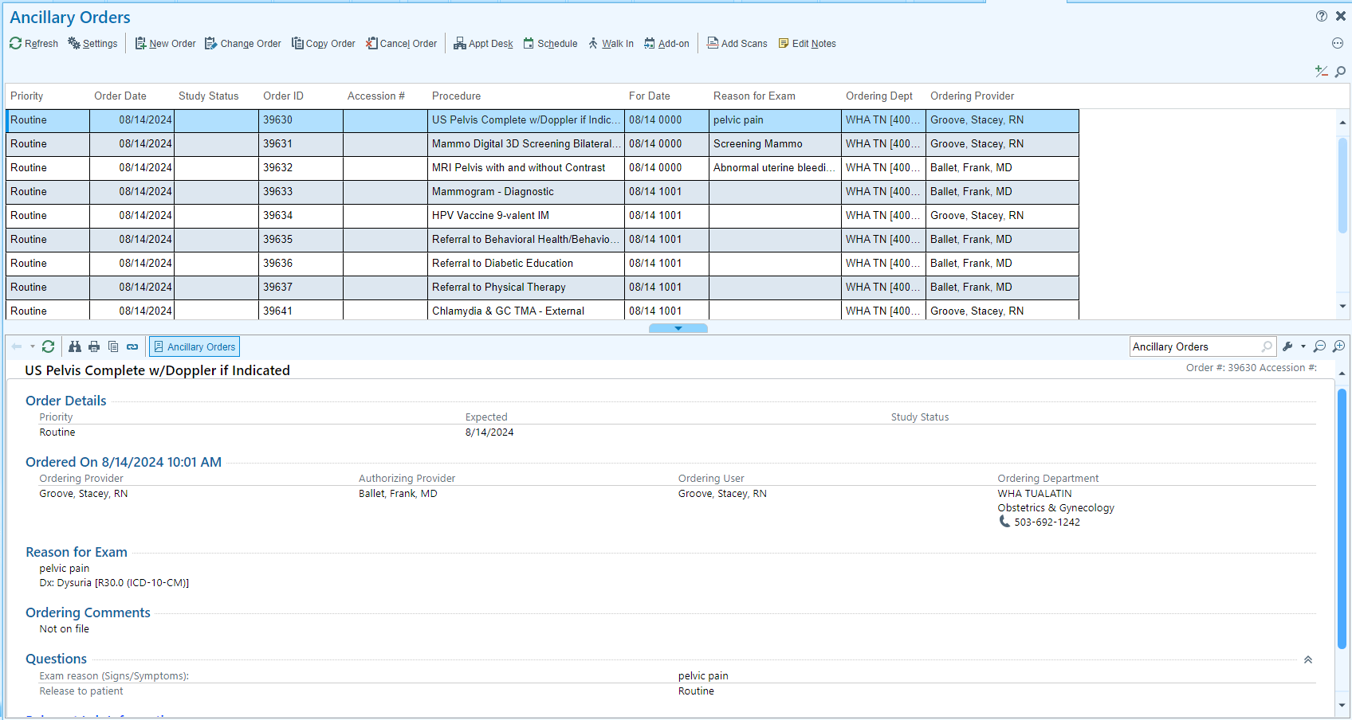

- Find the order that needs to be canceled and single click.
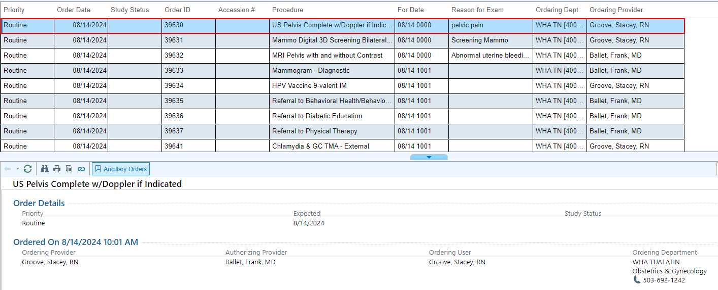
- Click Cancel Order

A Cancel Order window opens.
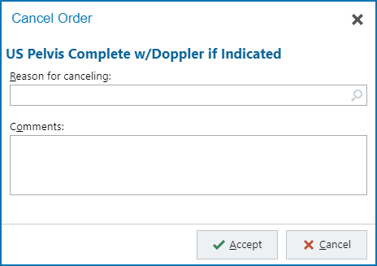

- In the Reason for canceling box click the magnify glass to find an appropriate reason.

- Click Accept.
- Your selected reason is now listed in the box.
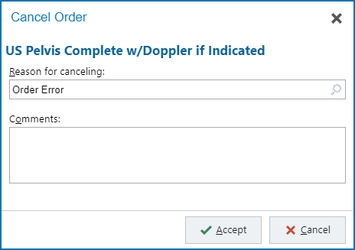

- Click Accept.
The order will now disappear.

Changing an Order from ANC Orders
Anc Orders is best used for changing WHA and Legacy based imaging orders only.
**Note: If you have an external order (anywhere outside of WHA and Legacy) you will need to cancel the order and put in a new order.**
In Ancillary Orders it can be difficult to tell at a glance which orders will be completed externally and which will be completed within WHA and Legacy. The best way to tell is to click the order and read through the Ordering Comments and Scheduling Instructions.
An example of the Ordering Comments in external imaging order:
An example of the Scheduling Instructions in a Legacy imaging order:
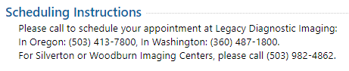
- Find the order that needs to be changed and single-click.
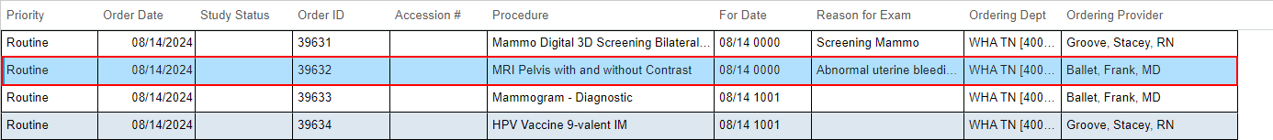

- Click Change Order

A Change Order window will open.
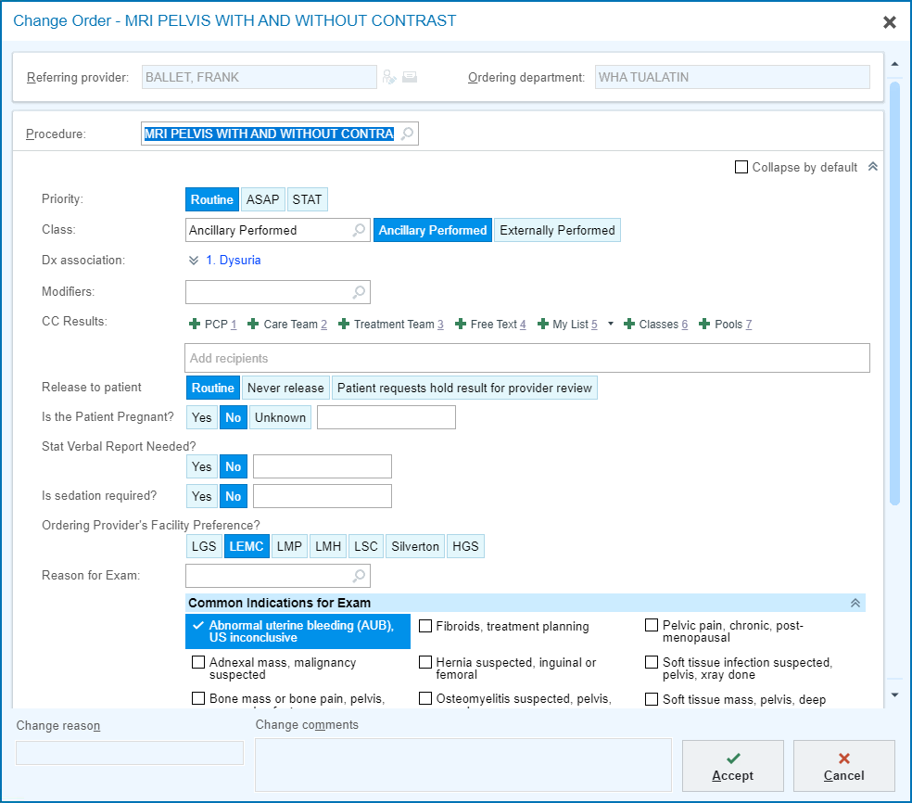

- Change the appropriate information.
- Click Accept.
A Provider’s window will open.
- Add the AMB Scheduled Ord Protocol to the Order Mode.
- Click Accept.
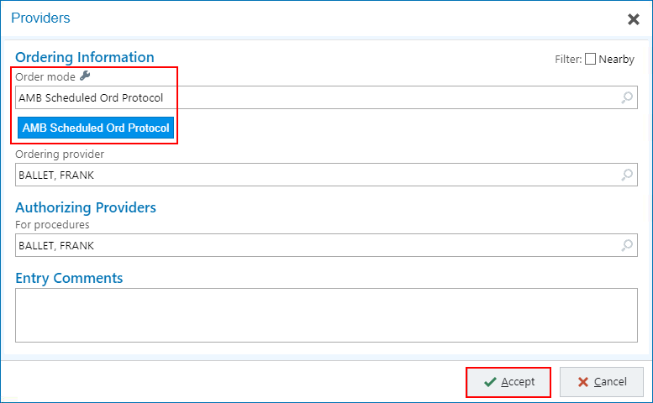

Deleting Pended Orders from a Canceled Appointment
When orders are pended during pre-charting and the appointment gets canceled or no-showed, it can sometimes leave orders in a Pending status. This can create some clutter in the chart and confusion around whether a lab has been ordered or not.
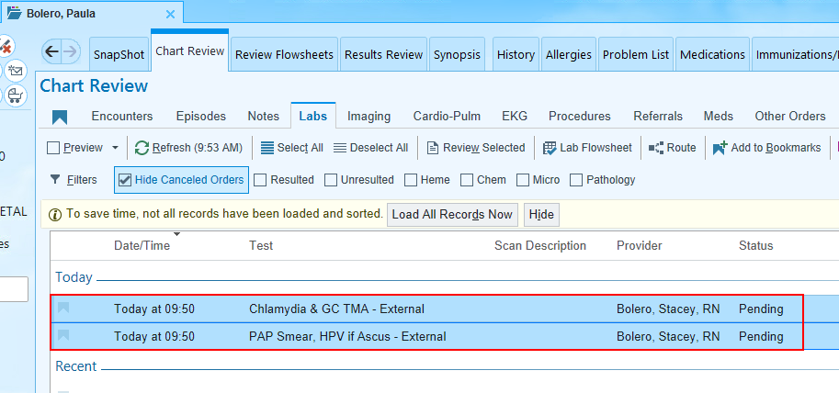
Here is the best way to cancel pending lab orders.
- Once in Chart Review, go to the Encounters tab.
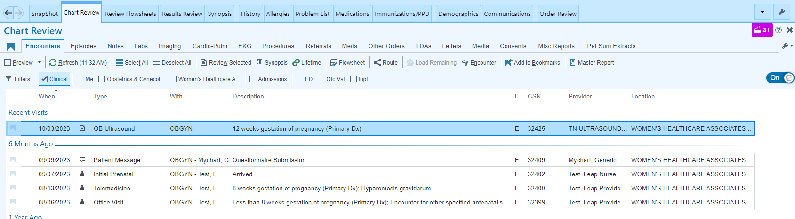

- Uncheck the Clinical filter box.
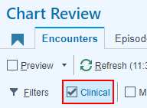
- Locate the canceled appointment and click to highlight.
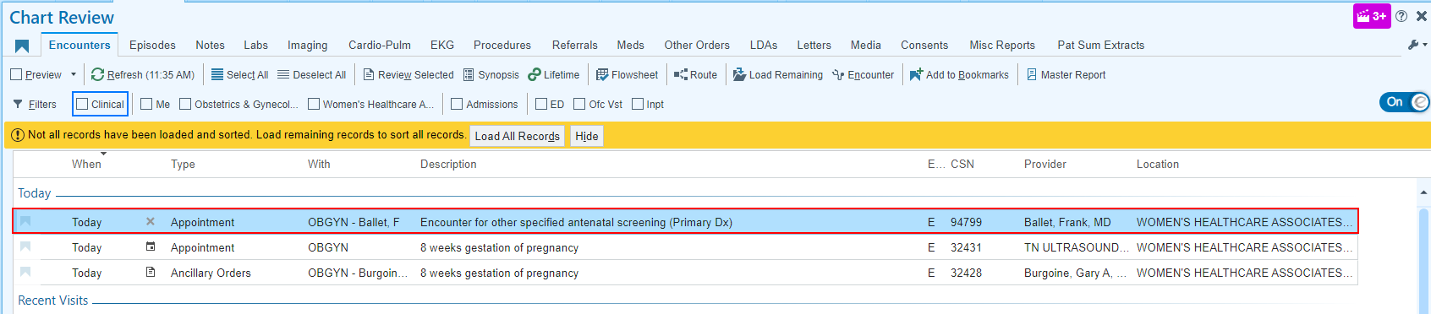

- Click the Encounter button to open the canceled appointment.
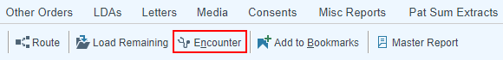

An appointment window will open.
- Click Continue.
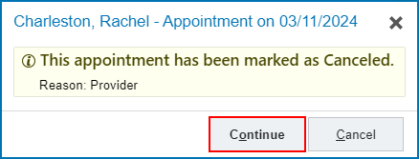

- In the bottom right corner of the screen, click the Unsigned Orders  button.
- Hover on the orders and click the X to delete the pended orders.
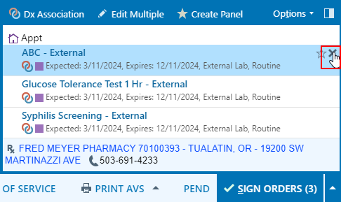

- Close out of the patient’s encounter.

